**Shubham E-commerce sales**

* **Data URL:** [**https://drive.google.com/drive/folders/1mY0agiWajOKDelUjIAADWMbB0q6kSz2p**](https://drive.google.com/drive/folders/1mY0agiWajOKDelUjIAADWMbB0q6kSz2p)
* **Data fields:**

**Table Name: Details**

|  |  |  |  |  |
| --- | --- | --- | --- | --- |
| Column name | Data type | Constraint | Distinct | Unique |
| ID | integer | Primary key | 1429 | 1429 |
| order_id | character varying | foreign key |  |  |
| amount | integer | - |  |  |
| profit | integer | - |  |  |
| quantity | integer | - |  |  |
| category | character varying | - |  |  |
| sub_category | character varying | - |  |  |
| paymentmode | character varying | - |  |  |

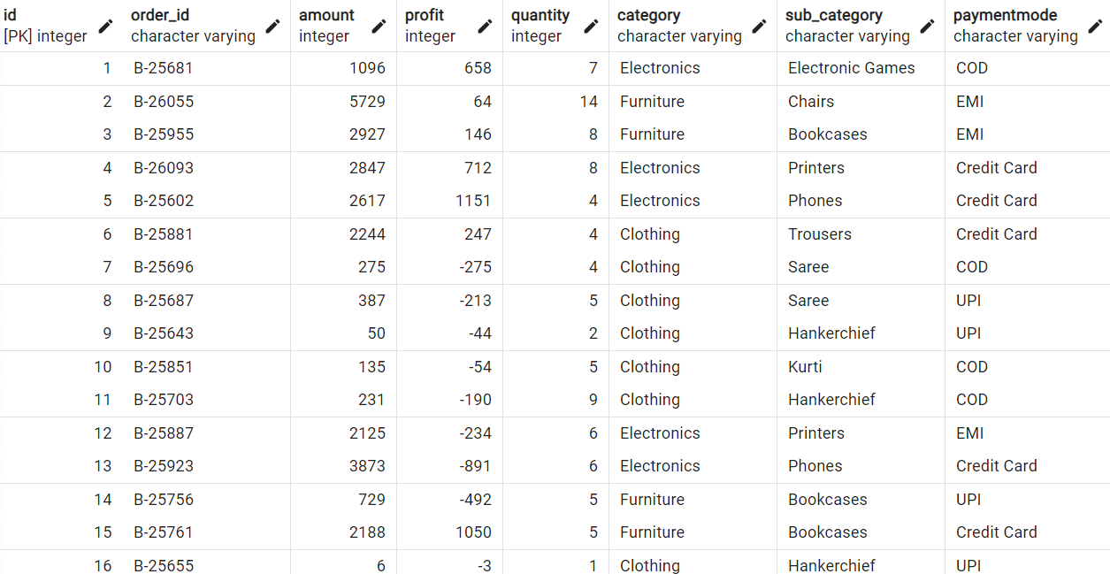

**Table Name: Orders**

|  |  |  |  |  |
| --- | --- | --- | --- | --- |
| Column name | Data type | Constraint | Distinct | Unique |
| order_id | character varying | Primary key | 500 | 500 |
| order_date | date | - | 307 | 231 |
| customername | character varying | - | 336 | 229 |
| state_ | character varying | - | 25 | 0 |
| city | character varying | - | 25 | 25 |

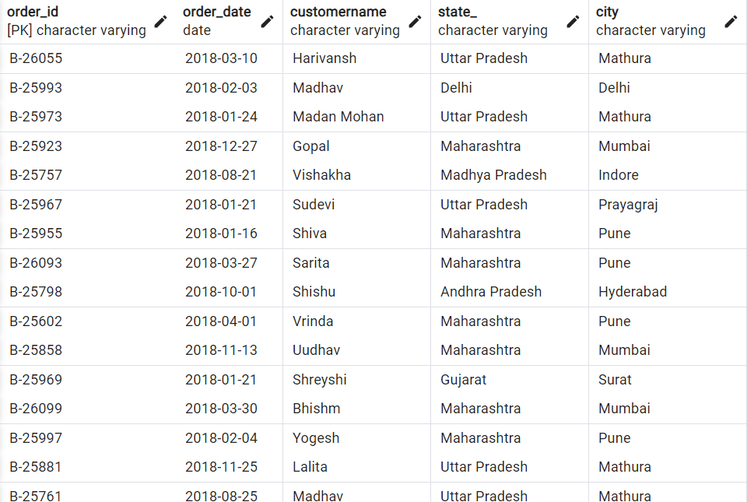

* **ERP model:**



|  |
| --- |
| paymentmode-dim  paymentmode  paymentmode_id |

|  |
| --- |
| Public details  ∑ amount  AOV  ∑ id  order_id  paymentmode_id  ∑ profit  ∑ quantity  sub_category |

|  |
| --- |
| Public orders  customername  order_date  order_id |

|  |
| --- |
| Region-dim    city  state_ |

1

1111

|  |
| --- |
| Category-dim  category  sub_category |

* **Power BI:**

**Questions:-**

1. Sum of profit by month.

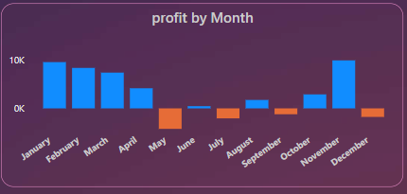

1. Sum of profit by sub category.

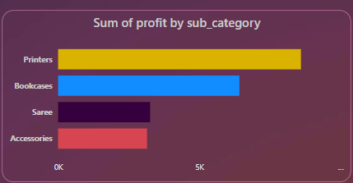

1. Sum of quantity by category.

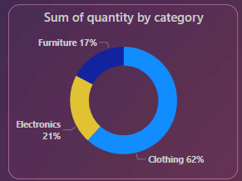

1. Sum of quantity by payment mode.

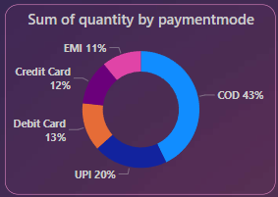

1. Sum of amount.

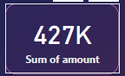

1. Sum of profit.

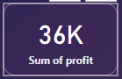

1. Sum of quantity.

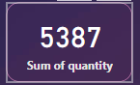

1. Sum of average of value.

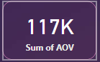

1. Sum of amount of top 4 state.

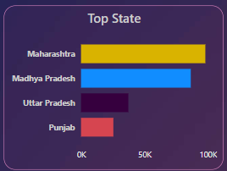

1. Sum of amount of top 5 customer name.

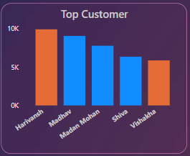

* **Dashboard:**

